Veteran Health Indiana
Richard L. Roudebush VA Medical Center
1481 West 10th Street, Indianapolis, IN 46202 PRESS RELEASE

FOR IMMEDIATE RELEASE
May 11, 2020

Richard L. Roudebush VAMC Announces New Medical Center Director
Laura Ruzick brings proven track record, leadership experience

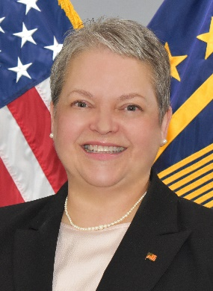
The Department of Veterans Affairs is pleased to announce the appointment of Ms. Laura (Christensen) Ruzick as the new Director of the Richard L. Roudebush VA Medical Center (VAMC) in Indianapolis, effective May 10, 2020. Ms. Ruzick has served as the acting Medical Center Director since September of 2019, and previously served as the Medical Center’s Associate Director since December 2016.

“We are excited to officially name Laura Ruzick as the new director of the Richard L. Roudebush VAMC,” said RimaAnn Nelson, Veterans Integrated Service Network (VISN) 10 Director. “Laura has a proven track record of success at VA Medical Centers throughout this region – including in Indianapolis. Her sound leadership qualities and proven experience will be valuable assets to the Richard L. Roudebush VA’s employees, volunteers, and -- most importantly -- to the Veterans we are honored to serve.”

Ms. Ruzick first joined the VA family in 2004 at the Hines VA, Chicago as a nurse manager. There she held leadership roles in developing clinical protocols, innovations in patient flow, and led initiatives in discharge planning. After directly serving our Veterans in a nursing role, Ms. Ruzick served as a Health Systems Specialist for VISN 10 in Cincinnati providing leadership support for the region.

Her commitment to Veterans and recognized leadership skills promoted her into an executive leadership role as the Associate Director of the Chalmers P. Wylie VA Ambulatory Care Center in Columbus, OH. While serving in this role, Ms. Ruzick led the Leadership and Communications workgroup of the National Veteran Access and Flow Task Force.

Ms. Ruzick earned her Bachelor of Science (BS) from Xavier University in Ohio, a BS in Nursing from Lewis University in Illinois, and her MBA also from Lewis University. She is a 2010 graduate of the Executive Career Field Development Program, a Certified Mentor, and a Fellow of the American College of Healthcare Executives.

Ms. Ruzick plans to continue to lead the Roudebush VA Medical Center in the areas of Veteran customer service, innovation and exceptional care, and support of their robust education and research missions.

For more information, contact Richard Griffith, richard.griffith@va.gov, 317-988-2420.

# # #

